KR MANGALAM UNIVERSITY



Secure Coding And Vulnerabilities Lab

ENSP351

Lab Assignments

Name - Sahil Chaudhary

Roll Number – 2301730193

B.Tech CSE AI/ML -( C )

2. Compiler Hardening Flags and UBSan/ASan Diagnostics

Ans 2
- No Flags –

Code –

#include <stdio.h>

int main() {

int a = 70000;

short s = (short)a;

printf("%d -> %hd\n", a, s);

return 0;

}

Output –

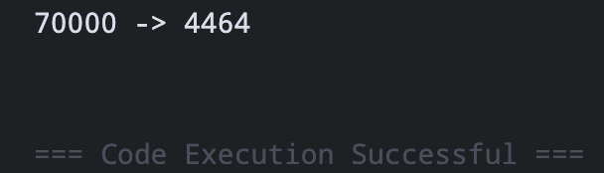

2.-Wall -Wextra (warning example) –

Code –

#include <stdio.h>

int main() {

int x = 3.14; // suspicious conversion

printf("%d\n", x);

return 0;

}

Output –

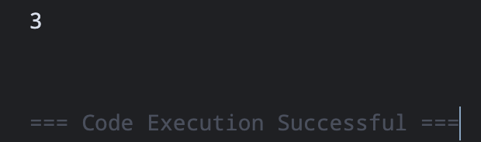

- UBSan Example

Code –

#include <stdio.h>

#include <limits.h>

int main() {

int x = INT_MAX;

int y = x + 1;

printf("%d\n", y);

return 0;

}

Output –

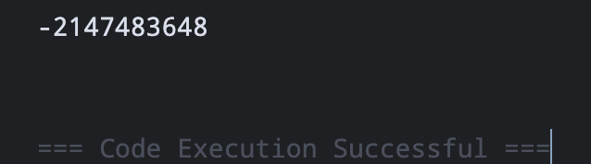

- ASan Example

Code –

#include <stdio.h>

int main() {

char arr[5] = "test";

arr[10] = 'A'; // Buffer overflow

printf("Done\n");

return 0;

}

Output –

